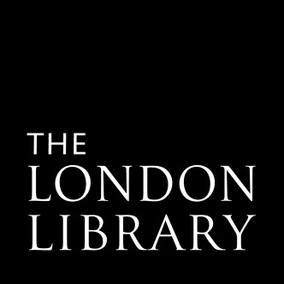

TRUSTEE APPLICATION FORM

Thank you for your interest in becoming a Trustee of The London Library. Please complete this form (including the equal opportunities monitoring sheet) and send FAO the Nominations Committee, The London Library, 14 St James’s Square, London SW1Y 4LG or by email to: director@londonlibrary.co.uk

Sunday 31 May 2026
(by midnight)
TRUSTEE

Vacancy: Deadline:
Candidate No (Office use only):

PERSONAL DETAILS

Title

Forename/s

Surname

Address Contact telephone numbers:

Home

Work

Mob

Post Code

Email

Section 1: Please explain briefly why you would like to be a Trustee of The London Library

.

Section 2: Please read the guide Becoming a Trustee guide and tell us what particular skills, knowledge and experience you could contribute to The London Library as a Trustee.

.

Section 3: Please provide brief details of your career or other relevant experience to date (you may also attach a CV if you wish).

.

Signed: _______________________ _ Date: ____________

Please note that all data will be held in the strictest confidence and in compliance with the Data Protection Act of 1998 and will only be used for the purpose of selection of candidates for trusteeship.
Section 4 - Equal Opportunities Monitoring

The London Library is committed to equal opportunities. To help us monitor this, please complete the questions below and send it with your application. The information you provide is used for no other purpose and will be treated as strictly confidential. This form will be separated from your application upon receipt and before selection takes place.

Job Applied For | Trustee |  | Candidate Number  (for London Library use only)
- Where did you hear about this vacancy?
(Please specify eg word of mouth, social media etc)

- How old are you?
- 16-24  - 25-34 |  | - 35-44  - 45-54 |  |  | - 55-64  - 65+  - Prefer not to say
- Do you consider yourself to have a disability or long-term health condition?
- Yes (Please specify) |  |  |  | - No  - Prefer not to say
4. Ethnicity monitoring: How would you describe yourself?
Asian or Asian British  - Chinese  - Indian  - Pakistani  - Bangladeshi  - Any other Asian background (please specify)  Black or Black British  - Caribbean  - African  - Any other Black background (please specify)  Other ethnic group  - Arab  - Other ethnic background (please specify) |  |  |  | White  - English  - Gypsy or Irish Traveller  - Irish  - Scottish  - Welsh  - Any other White background (please specify)  Mixed  - White and Black Caribbean  - White and Black African  - White and Asian  - White and Chinese  - Any other mixed background (please specify)  - Prefer not to say

- Your religion, belief or culture
- No religion  - Buddhist  - Christian (all denominations) | - Hindu  - Jewish  - Muslim | - Sikh  - Other (please specify):  - Prefer not to say

- Gender monitoring: Would you describe yourself as:
- Male  - Female | - Non-binary  - Transgender male | - Transgender female  - Prefer not to say

- Sexual orientation: How would you describe yourself?
- Bisexual  - Homosexual | - Heterosexual  - Other |  | - Prefer not to say
- Education/Socio-economic background
If you went to university, were you part of the first generation of your family to do so? | - Yes | - No | - N/A | - Prefer not to say
Did you mainly attend a state or fee-paying school between the ages of 11-18 | - State | - Fee-paying | - Attended school outside UK | - Prefer not to say

